Multitasking
# Source: AI Source: Provided by: [Data Path: Persons Table -> ID Column: 1, Name_En Column: Motasem Essam] -> From: [ChatGPT] on [1/21/2026]
Multitasking is a core concept in both Operating Systems and Real-Time Systems (RTS) that allows a system to execute multiple tasks seemingly simultaneously by efficiently sharing resources like the CPU.

Definition
# Source: AI Source: Provided by: [Data Path: Persons Table -> ID Column: 1, Name_En Column: Motasem Essam] -> From: [ChatGPT] on [1/21/2026]
Multitasking is the ability of a system to run multiple tasks or processes at the same time, by switching between them rapidly.
- In single-core systems, this gives the illusion of simultaneous execution.
- In multi-core systems, tasks can run truly in parallel.

Key Features
# Source: AI Source: Provided by: [Data Path: Persons Table -> ID Column: 1, Name_En Column: Motasem Essam] -> From: [ChatGPT] on [1/21/2026]
- Task Switching (Context Switching)
  - The CPU switches between tasks to give each task a turn to execute.
  - Each switch preserves the state of the current task so it can resume later.
- Scheduling
  - Tasks are scheduled based on priority, deadlines, or fairness policies.
  - Preemptive scheduling allows high-priority tasks to interrupt lower-priority tasks.
- Resource Sharing
  - Tasks share CPU, memory, I/O devices, and other resources efficiently.
  - Requires synchronization mechanisms (semaphores, mutexes, monitors) to prevent conflicts.
- Responsiveness
  - Improves system responsiveness, especially for interactive or real-time tasks.

Types of Multitasking
# Source: AI Source: Provided by: [Data Path: Persons Table -> ID Column: 1, Name_En Column: Motasem Essam] -> From: [ChatGPT] on [1/21/2026]
- Cooperative Multitasking
  - Tasks voluntarily yield control of CPU.
  - Risk: A task that never yields can block other tasks.
- Preemptive Multitasking
  - OS or scheduler forces a task to yield CPU after a time slice or when a higher-priority task arrives.
  - Used in most modern OS and real-time systems.

Example
# Source: AI Source: Provided by: [Data Path: Persons Table -> ID Column: 1, Name_En Column: Motasem Essam] -> From: [ChatGPT] on [1/21/2026]
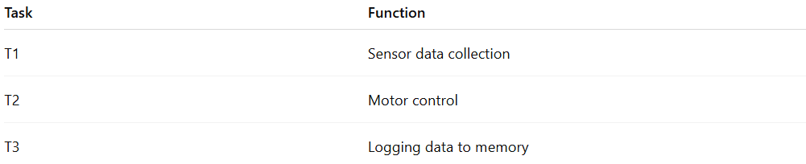
Suppose a robot controller handles three tasks:
Task | Function
T1 | Sensor data collection
T2 | Motor control
T3 | Logging data to memory
- Multitasking OS: T1, T2, and T3 share the CPU.
- Scheduler ensures T2 (critical motor control) runs immediately when needed.
- Context switching allows all tasks to progress without missing deadlines.

Advantages
# Source: AI Source: Provided by: [Data Path: Persons Table -> ID Column: 1, Name_En Column: Motasem Essam] -> From: [ChatGPT] on [1/21/2026]
- Efficient resource utilization – CPU is never idle unnecessarily.
- Improved responsiveness – critical tasks can run promptly.
- Supports real-time system requirements.

Disadvantages
# Source: AI Source: Provided by: [Data Path: Persons Table -> ID Column: 1, Name_En Column: Motasem Essam] -> From: [ChatGPT] on [1/21/2026]
- Context switching overhead – frequent switching wastes CPU cycles.
- Complex synchronization – shared resources can lead to race conditions or deadlocks if not managed carefully.
- Can increase system complexity for real-time guarantees.

Why Multitasking Matters for Software Engineers
# Source: AI Source: Provided by: [Data Path: Persons Table -> ID Column: 1, Name_En Column: Motasem Essam] -> From: [ChatGPT] on [1/21/2026]
- Fundamental for designing operating systems, RTOS, and embedded systems.
- Teaches task scheduling, resource sharing, and synchronization.
- Crucial for robotics, industrial automation, multimedia, and networked real-time applications.

